

**Literature Review on**

**Survey Equipment Rental**

Student ID : 2358836

Student Name : Mausham Dhakal

Group : L6CG19

Supervisor : Nikunja Lamsal

Reader : shiv Kumar Yadav

Submitted On :01-02-2025

**Table of Contents**

**Literature Review** 4

**Cost Benefits Analysis of Renting vs Buying** 4

**Logistic and Operational Challenges** 5

**Ecommerce in Rental Business** 5

**Rental platform Security and Trust Mechanism** 6

**Customer Behavior and Preferences in Rental Services** 8

**Case Studies and Market Demand** 8

**Sustainability and Environment Impact of Equipment Rentals** 10

**Similar Related Work** 10

**Asian Techno Traders** 10

**Office Materials Nepal:** 11

**Surveying Concern:** 12

**REFERENCES** 13

**Table of Figures**

Figure 1: E-commerce Cycle. ......................................................................................................................... 7

Figure 2: E-commerce market by Region. ..................................................................................................... 9

Figure 3: Asian Techno Traders. .................................................................................................................. 11

Figure 4: Office materials system. .............................................................................................................. 12 Figure 5: Surveying Concern. ...................................................................................................................... 12

# Literature Review

## Cost Benefits Analysis of Renting vs Buying

The paper analysis of renting versus buying, the author undertakes critical review on the various economic aspects that are involved in the decisions of organizations on whether to own or hire their property, especially the fixed or equipment. Some of the points that the paper makes include the first-time outlay of capital for the purchase out right, annual recurring charges to maintain the machinery over a long time, depreciation charges, and rental flexibility. Outsourcing is deemed appropriate for companies where particular equipment is not required on a daily basis since renting makes it possible for the businesses to save their cash that they would have used to purchase the equipment, maintain them, store them, and bear the expenses if they depreciate. On the other hand, purchase is usually in the best interest of the business entities that use equipment regularly for an extended period because after sometime the total cost could be higher than out-right purchase of the assets.

Interestingly, these concepts can be easily applied to the framework of my project: a survey equipment rental platform. Instruments like total stations, theodolites, UAVs, GPS receivers, levels and other accessories are costly assets for small business and individual practitioners. Far [these professionals], the acquisition of such costly machines may be unrealistic, particularly when the equipment is going to be used for certain activities or occasional work. The following advantages are pertinent to hiring these tools on demand, one time and as required.

In addition, rental of survey equipment is more advantageous than ownership since those to be used in particular projects can be hired while the contractors do not need to store or maintain other equipment’s that might not be frequently used. The general discussed aspects of cost-saving in case with renting are justified for businesses in the survey industry because the kinds of projects that they may occur and equipment required can be quite different. In this regard, the findings of the paper about the benefits of rent to the disadvantage of home ownership are useful for surveyors and the small businesses who wish to reduce their spending.(Rivers,

2017)

## Logistic and Operational Challenges

It is necessary to specify that the paper reveals several more concerns essential for practical implementation of EV and operation and management of logistics vehicles in the transportation sector. All these challenges are most applicable in businesses such as survey equipment rental as they experience similar operational issues. In survey equipment rental, the matters of concern include the movement of the equipment through great distances, timely delivery and collection of large bulky equipment and guaranteeing on the equipment. Due to the surveying, it becomes important to have the right routes and right time when the surveyors need to be supplied with the necessary equipment’s.

Similarity may also be noted where there is necessary to charge infrastructure for EVs: so necessary is to store, maintain, and calibrate the surveying equipment. In both cases, the process of creation and service provision of such facilities is expensive, although which are crucial to effective functioning. Additionally, with reference to the routing for EVs, rental of survey equipment requires routing to factor time for equipment re-calibration and general maintenance so that equipment does not seize up at some point during key surveys. Both industries also face the challenge of real-time location tracking to guarantee positioning of vehicles and equipment’s on right tracks to save time and avoid wastage.(Juan et al., 2016)

## Ecommerce in Rental Business

After reviewing the paper, it becomes evident that the principles under discussion can be successfully applied in survey equipment rental business. The paper also describes how e-commerce system enhances the rental through making products easily accessible by customers, avoiding close contacts, and enhanced operation (Author, Year). This is even especially with the survey equipment rental market, generally speaking the equipment is expensive and specific, and is only needed by the renter for a short period. The existing model of e-commerce can be applied to survey equipment rental platforms and provide a simple and convenient web frontend where surveyors can filter equipment, make bookings, and pay for total stations, drones, and GPS online.

Inventory management and availability of stock are also discussed in the paper, it is impartial for a rental business (Author, Year). When it comes to survey equipment, this feature would help the customers always know which of the equipment are available for hire, and this would work to matters such as overhiring whereby some of the instruments hired are not returned on time or what is worse, are not available when they are needed. Also, the dislocation of payment systems together with a flexibility of price setting as captured in this paper, offers the surveyor an opportunity to hire equipment from whoever is offering the best price depending on his project period.

Similarly, benefits outlined in the paper as applying customer data analytics for recommendation of specific surveys, would be valuable in the survey rental market. We could recommend specific equipment for the surveyed rental businesses based on previous rentals or their required projects, so as to enable them hire the right equipment for their tasks. In sum, implementing these e-commerce strategies into survey equipment rental industry can cut cost down, increase utilization of resource, and increase overall client satisfaction.(Chukurna et al., 2024)

## Rental platform Security and Trust Mechanism

The topics relevant to the paper was chosen with reference to the growing threat of security issues in e-commerce, and the heightened need to protect customer’s information in the digital era of shopping. It focuses on the concept of the digital ecommerce buying process which covers various processes also known as stages including, Consideration, purchase, and communication. During every development phase, there are threats like unauthorized access to business site, leakage of information or fraud that may erode customer trust and business credibility. Paper pointed out relevant instruments required for guarding ecommerce transaction which include fire-wall, encryption application, and digital certificates, which provide confidentiality, integrity, and authenticity. It also goes further to provide an account of security privileges including access control, nonrepudiation, and audit, which is critical in in the provision of secure online shopping environment.

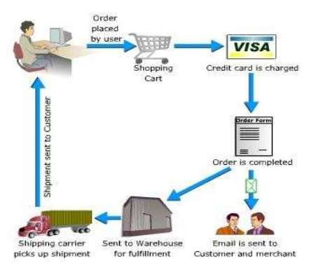

*Figure 1: E-commerce Cycle.*

The paper covers main e-commerce security issues such as denial of services (DOS), unauthorized access, and fraud as well as the measures taken to avoid these risks. There are methods such as encryption and digital signature described as the basic technologies that should be used in order to avoid interception and guarantee secure business transactions. The paper also emphasizes the importance of exercising security reviews and user awareness as well as applying best practices to sustain e-commerce security against potential future IT threats. The finding of the study is that e-commerce security is an evolving process where companies have to constantly evolve their approaches to protecting customer information and establishing trust. This is important to the achieving of the goal of e-commerce sites and to the creation of a safe and stable retail space for the audience.(Niranjanamurthy & Chahar, 2013)

## Customer Behavior and Preferences in Rental Services

The findings presented in the paper specify that the pandemic has led to a new consumer attitude characteristic by speed, safety, and convenience with a strong focus on omnichannel. Therefore, in the same manner as survey equipment rental business, these trends are also valid. The increased focus on touchless rentals and. Restricted customer interactions also mean that customers are now demanding fast, convenient and safe rentals. Similarly, as such concepts like safe and contactless payment during checkouts are becoming popular and introduced by retail businesses, the same should be applied to rental platforms: contactless pick and return of equipment should be allowed together with digital payment options.

Another major factor that can be derived from the paper is the use of real-time consumer feedback via what is received through social media where firms are in a position to determine evolving consumer trends a move that helps them to alter their operations. This idea is most of essential for a rental service business because knowing the customers’ demands and tastes would enable the company to adjust equipment supply, and price and promotion tactics. Retailers can reflect the feedback from their customers and the trends on shared platforms with rental platforms with an attempt to enhance the customer base and to attract the existing consumers with special offers and promotions, free period/or deeper discounts, or special bundle offers.

This paper has also argued the need to being flexible when making decisions to respond to the new desires of consumers. This can be applied to the rental industry by using a variable pricing structure, customized rental plans according to a customer’s preferences, and using the miscellaneous variations in currents and proposed stock levels..(Holly et al., 2020)

## Case Studies and Market Demand

I observed that while reading the paper on the challenges facing the e-commerce industry it was possible to identify areas where these problems could be specifically formulated to suit the creation of a survey equipment rental platform. Recall that one of the factors threatening the company’s success is the weak digital marketing competencies that ultimately affect brand recognition and customer loyalty and acquisition. The survey equipment rental business is a competitive niche thus as I go ahead with my platform, I realize the need to integrate strong online marketing techniques. This shall be vital for attracting the right clientele, especially focusing on small businesses, sole traders, surveyors, landlords or any person of necessity when it comes to hiring rental equipment. On this count, I can harness social media networks and other online animals effectively to counter this challenge and popularize the platform.

The second problem arising from this is that there are higher risks associated with fraud and data security on the online platform. The paper brings out the fact that issues of security and particularly customer transaction and business networks are very vital in the case of e-commerce. Since my platform will deal with renting survey equipment, the data involved requires secure transactions and protection of user data. Some of the protections that I will put in place include: use of encryption, MFA, and secure payment processing to protect both client and corporate information. This will assist in the creation of trust and thus the credibility of the created platform.

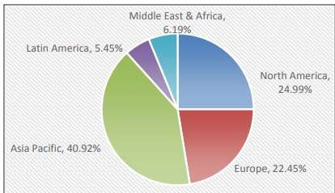

*Figure 2: E-commerce market by Region.*

The paper also features information on compliance with health and safety regulations, which while more applicable to physically tangible products, also applies to survey equipment rentals two aspects will be key for both the customer satisfaction as well as the credibility of the platform; The regular maintenance of equipment and compliance with safety requirement. At last, the experiences and findings delineated in the paper strike a thus far very apt chord with my platform.

Concerning logistics operations, issues such as delay in receiving equipment can affect the customer experience in a very big way.(Mohammad Aghaei et al., 2021)

## Sustainability and Environment Impact of Equipment Rentals

The paper focuses on sustainability prospects for the fashion rental industry which gives the necessary ideas for the survey equipment rental business. The significance of cleanliness and safety protocol presence is another thing. Similar to fashion rental services that see the clothes washed before being rented out, a survey equipment rental platform should also clean equipment such as total stations, GPS systems, and drones among others before renting them out. This would not only increase the life span of the equipment but also give customers that much needed confidence that the equipment is not only safe to use, but standard as well.

Communication is also found to be relevant as supported by the article. Competing factors in the fashion rental sector include the definition of rental terms and conditions, precautions taken, and price offered to the customers. Likewise, at a survey equipment rental platform there should be stated policies on how long a piece of equipment can be rented, how to use the equipment, and what to do in case of an adverse event.

While fashion companies make their brands responsible for ethical labor and community support, a survey equipment platform can benefit small business, independent surveyors, and educational institutions that will be able to acquire quality equipment for a reasonable price. Most of these efforts help not only in building customer loyalty but also in the growth of the industry.(McCoy & Chi, 2022)

# Similar Related Work

## Asian Techno Traders:

Asian Techno Traders Pvt. Ltd. is one premier suppliers of survey equipment rentals in the market in Nepal. Total Stations, Auto Levels as well as other surveying equipment; available from the website has undergone various tests by experienced technicians. The full inventory of the bikes and the details about renting -inventory, pricing and availability, and other features of the bikes are available to users registered on the site. It also has background information about the industry and current developments. Qualified workers help to choose a suitable tool to the customer.



*Figure 3: Asian Techno Traders.*

## Office Materials Nepal:

Office Materials Nepal offers wide range of surveying and construction instruments for sale which include; Total Stations, Digital Theodolites, and Leveling Machines. It is a reliable supplier of surveying and measuring instruments that serves the requirements of various professionals of Nepal. It deals with supplying quality products for several sectors such as construction and surveying. But they appear not to provide rental service for these products.

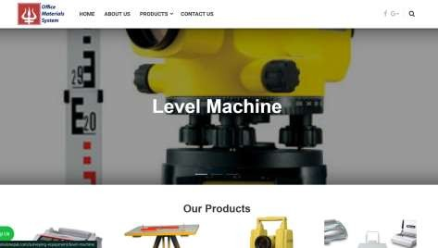

*Figure 4: Office materials system.*

## Surveying Concern:

Surveying Concern offers surveying instruments like Total Stations, GPS and Digital Theodolites primarily selling its own products. They supply surveying equipment to surveyors and civil engineers in Nepal, but they don’t have the retail service for internet shopping or equipment rental. Unlike most online based companies, their main focus involves coming into direct contact with the consumers.

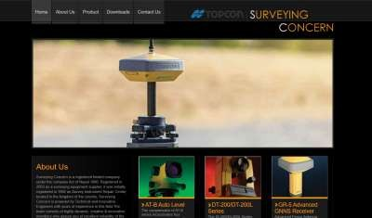

*Figure 5: Surveying Concern.*

# REFERENCES

Chukurna, O., Tardaskina, T., Chaikovska, M., Nitsenko, V., Pankovets, L., & Kofman, V. (2024). Transformation of E-Commerce Business Modelsin the

Digital Economy. *Naukovyi Visnyk Natsionalnoho Hirnychoho Universytetu*, *5*,

192–199. https://doi.org/10.33271/nvngu/2024-5/192

Holly, B., Anne, K., Alex, R., & Kelly, U. (2020). *Adapting to the next normal in retail: The customer experience imperative (The COVID-19 crisis has led to dramatic shifts in consumer behavior.Retailers will have to work hard to meet ever-evolving customerexperience requirements in order to win and rem*. *May*.

Juan, A. A., Mendez, C. A., Faulin, J., De Armas, J., & Grasman, S. E. (2016). Electric vehicles in logistics and transportation: A survey on emerging environmental, strategic, and operational challenges. *Energies*, *9*(2). https://doi.org/10.3390/en9020086

McCoy, L., & Chi, T. (2022). Collaborative Consumption: A Study of Sustainability Presentation in Fashion Rental Platforms. *Sustainability (Switzerland)*, *14*(14). https://doi.org/10.3390/su14148537

Mohammad Aghaei, Sahebi, A. G., & Kordheydari, R. (2021). Investigating the Change in Customers’ Sustainable Consumption Behaviour after the Outbreak of COVID-19. *International Journal of Applied Marketing and Management*, *6*(1), 34–49. http://ijee.ieefoundation.org/vol2/public_html/ijeeindex/vol2/issue4/IJEE_03 _v2n4.pdf

Niranjanamurthy, M., & Chahar, D. (2013). The study of E-Commerce Security

Issues and Solutions. *International Journal of Advanced Research in Computer*

*and Communication Engineering*, *2*(7), 2885–2895.

Rivers, A. (2017). International innovator. *Dance Magazine*, *91*(2), 60.